Research on Teaching and Learning at McMaster University: A Discussion

Paul R. MacPherson Institute for Leadership Innovation and Excellence in Teaching and Learning

Terms matter. Whether we call something “scholarship of teaching and learning,” or “pedagogical research,” or “educational research,” or “research on teaching,” it matters. It matters for who understands the work signified by the term, who feels welcomed to participate in that work and for how that work is recognized and supported across McMaster University.

At the Paul R. MacPherson Institute for Leadership, Innovation and Excellence in Teaching and Learning we are tasked with cultivating an environment where learning deeply matters, and teaching is valued and recognized by the collective McMaster community. Part of that ambitious vision is to support, conduct and recognize something we have, in recent years, called teaching and learning scholarship.

When we collaboratively developed our vision, mission, and mandate in 2019 we at the MacPherson Institute recognized the varied and often conflicting terms for research on teaching and learning across the University, and indeed across the higher education landscape in Canada. In 2019 we used “teaching and learning scholarship” as an umbrella term that would encompass all kinds of scholarly work focused on teaching and learning. We knew then what we called this work at the MacPherson Institute and at McMaster needed to be tested and refined.

Between 2019 and 2021 we consulted with educators across the campus through a survey and through interviews, and we reviewed a wide body of literature on teaching and learning research and scholarship to understand how the McMaster community and the higher education community labels and describes this work. We also explored how faculty and staff engage with this literature and their motivations for doing so.

We did this consultative work so that we could return to the campus community a clear message on the term for teaching and learning research and scholarship that is most resonant at McMaster.

Based on our consultations with the McMaster community, our consideration of the literature, and our awareness of complexities in both these spaces, we offer “research on teaching and learning” as the term with broad, if not perfect, consensus for this work. Again, drawing from our consultations with the McMaster community as well as the higher education literature, we understand research on teaching and learning to mean the systematic inquiry into teaching and learning. Research on teaching and learning draws on a variety of methodologies and may or may not involve dissemination of this research in peer-reviewed settings.

We appreciate that in some areas of the University other terms for this work will be used more frequently and better understood (e.g., scholarship of teaching and learning, research in andragogy, scholarly teaching, educational research, pedagogical research). We also recognize that the literature reflects a history and continued engagement with these terms, with categories like ‘good teaching,’ ‘scholarly teaching,’ and ‘the scholarship of teaching and learning’ (McKinney, 2007) introduced to organize different approaches and make distinctions among ways of engaging. While we note these differences, and put forward “research on teaching and learning,” we do so without expectation that any area change the terms they use at the expense of introducing confusion, doubt, or division.

Rather, we offer “research on teaching and learning” as a McMaster term for this work to do a few things. Most simply, sharing a term allows us to understand one another and the work signified by the term. It helps our students understand this work, as well as our colleagues and administrators.

Having a shared understanding of the work of research on teaching and learning also allows a deeper recognition of its value. While intrinsic motivation for engaging in research on teaching and learning remains the most dominant reason for McMaster educators to engage in this work, there is a shared desire to see research on teaching and learning more fully integrated into hiring and tenure and promotion practices. At the MacPherson Institute we advocate for policies and practices that will see teaching valued and recognized. We expect that with this consultatively informed term of research on teaching and learning we will be able to extend this advocacy beyond navigating terminology into deeper discussions of value and impact.

This shared understanding of research on teaching and learning invites us at the MacPherson Institute to enhance our existing supports for this work. While we routinely offer consultations, grants, research summaries, and networking opportunities, we learned through this consultative process of desires for continued and greater support in entering the work of research on teaching and learning and for further advocacy in the inclusion of research on teaching and learning in policy.

Finally, our work at the MacPherson Institute has, over many years, also contributed to this body of research on teaching and learning through the work of our staff and post-doctoral fellows. Now that we have this shared, and community informed, term for this work, we see similar opportunities for continuing this research generation while also doing more to celebrate the value and impact of research on teaching and learning generated by our team.

No term for this work was ever going to be perfect. Disciplinary differences, entry points, expectations for recognition, and value and roles within the University make perfect agreement to a term impossible and not necessarily desirable. With our varied terms we have across the University nuanced conversations and specific contextual meanings. With this variety though, there will still be moments of confusion, moments where the words we use will be misunderstood or the impact of this work called into question. At the same time, we know and trust the value the McMaster community holds for research on teaching and learning and for excellence in teaching and learning. From this shared understanding of one term, we know we have more work to do.

In what follows we describe the collaborative process we undertook to uncover the different understandings, ways of engaging, and valuing of research on teaching and learning. We share the perspectives of educators from across campus as well as the literature informing research on teaching and learning in higher education across Canada. We conclude with suggestions for what work might come next for us at the MacPherson Institute, including advocacy and support for embedding research on teaching and learning into policies and procedures at all levels of appointment and across all faculties. While we will continue to share our next steps at the MacPherson Institute with you, we welcome and encourage you to connect with us with ideas of your own.

Title: Results from an Environmental Scan of Research on Teaching and Learning: Across McMaster University
Authors: Kelsey Harvey, Celeste Suart, Erin Aspenlieder, Julia Evanovitch, Fairuz Karim, Alyssa Minhas, Jacob Krone, Martha Cassidy-Neumiller, and Alise de Bie
Acknowledgements: Kim Dej, Lori Goff, Nancy Fenton; Andrew LoGiudice, Melec Zeadin, Cherie Woolmer, Lynn Martin, Jonathan Sherbino, Robert Fleisig, Jennie Vengris, Felicia Vulcu, Stephanie Verkoeyen, Elliot Storm, and Katrina Espanol-Miller.
Additional Acknowledgements: Steven Sears, Biljana Njegovan, Emily Hynes, and Trish Sarnicki.
Thank you: Our sincere gratitude to all participants who took the time to fill out the survey and/or participate in the interviews.
Please see appendix (Table 1) for outline of contributions.

Introduction
McMaster has a global reputation as an award-winning institution for innovation and excellence in teaching (McMaster University, 2021). Vajoczki and colleagues (2011) theorized that McMaster’s reputation may inspire McMaster faculty and staff to engage in research on teaching, learning, and education. Other scholars have also argued that support from teaching and learning centres, like the MacPherson Institute at McMaster, may also play a vital role in facilitating faculty and staff involvement in teaching-and learning-related research (Kolomitro et al., 2018; Vander Kloet et al., 2017). Toward this aim, Marquis (2013) called for the MacPherson Institute (then MIIETL) to work with the broader McMaster campus to create a network of faculty and staff who engage in scholarly and research activities on topics related to teaching, learning, and education.
In 2018, McMaster conducted a Review of the function of Teaching and Learning at McMaster. This review included the development of a teaching and learning self-study that was led by the MacPherson Institute in collaboration with other campus services and academic units (MacPherson Institute, 2019). In so doing, this self-study identified several key initiatives to help advance the mission of the MacPherson Institute mission to “to explore, enhance, support, and recognize teaching and learning experiences at McMaster” (MacPherson Institute, 2022, para, 1) through collaboration and achieve its mandate to support, conduct, and recognize “teaching and learning scholarship that has the capacity to develop, inform, and enhance educational initiatives and student learning” (MacPherson Institute, 2020, p. 3) in partnership with educators. One such initiative called for creating “A Shared Understanding of the Value of Teaching and Learning Scholarship,” or SoTL, across campus. This shared understanding of the value of SoTL has been identified in extant literature as a larger-scale concern at post-secondary institutions.
To understand the intention behind this initiative, one must first understand what is meant by SoTL. There are three interconnected categories that describe the Scholarship of Teaching and Learning (McKinney, 2007). The first is “Good Teaching,” whereby instructors reflect on the methods and approaches they employ to engage students in their learning. The second is “Scholarly Teaching,” wherein instructors embed a scholarly approach to their teaching by engaging and being informed by the literature, as well asking questions about the learning environment. The this is “Scholarship of Teaching & Learning,” whereby instructors engage in both reflective and scholarly teaching, but also conduct research on teaching and learning with the aim of enhancing their own practice, as well as publicly sharing their findings. This research specifically addressed the third category, the “Scholarship of Teaching & Learning,” with particular attention to research on teaching- and learning-related topics. However, some participants in our study spoke to reflective and scholarly teaching, because these practices are closely interconnected and aligned with SoTL. We have included these findings in our report where appropriate.
With this in mind, researchers affiliated with the MacPherson Institute undertook an environmental scan with the goal of ascertaining the breadth of teaching and learning scholarship taking place across the various Faculties at McMaster University. In this report, we share the results of this scan, which consisted of a university-wide survey, interviews with key faculty across campus, and mining of the titles of academic journals that publish relevant work. Herein, we sought to identify the range of ways faculty/staff name and describe systematic inquiry into teaching and learning, how faculty/staff engage with scholarly literature on teaching and learning, and how faculty/staff are motivated to engage in research on teaching and learning. We hope that the sharing of the findings of this environmental scan will help support dialogue aimed at a common understanding of the value of teaching and learning scholarship at McMaster.

Literature Review
Before proceeding, we would like to acknowledge that the corpus of literature reviewed in the section that follows is predominantly drawn from the field of the scholarship of teaching and learning [SoTL]. We recognize this as a limitation of this report, as there are many disciplines at McMaster University with scholars who are renowned leaders in various educational fields (e.g., critical pedagogy, medical education, and more). In keeping this literature review exclusive to SoTL, our intent was not to exclude these groups, disciplines, or important educational or pedagogical fields of study. Rather, the rationale for this was twofold. First, like many teaching and learning centres globally, the MacPherson Institute’s work is situated in the field of SoTL. Meaning, SoTL literature and principles are embedded into the education and practices that MacPherson Institute staff advance. Being that this report serves to speak on behalf of the MacPherson Institute to stakeholders across campus, our use of SoTL literature is to demonstrate our epistemological positionalities. Second, SoTL is viewed as disciplinarily neutral (Miller-Young et al., 2017). By reviewing SoTL literature, we can provide context from the perspective of teaching and learning centre staff without privileging any one discipline. Should we have included the perspectives of a few disciplines in the literature review, we would have done so at the exclusion of other disciplines. Therefore, we recognize that the following review is limited, and future reviews of the literature should include a comprehensive examination of all disciplinary perspectives.

Naming and Describing Systematic Inquiry into Teaching and Learning
In naming and describing research on teaching, learning, and education, the MacPherson Institute has in the last few decades used the phrase the Scholarship of Teaching and Learning [SoTL]. SoTL was first coined by Boyer (1990) roughly 30 years ago and is now described as an international movement accessible to researchers from every discipline (Webb, 2020). While the definition of SoTL is has evolved over time, a process Simmons and Marquis (2017) describe as an emergent, developmental process, SoTL’s definition remains contested (McKinney, 2006; Tierney, 2017; Vithal, 2018). However, many scholars agree that SoTL includes systematic reflection on teaching practices and student learning, as well as disseminating results and integrating findings into teaching practice (Society for Teaching and Learning in Higher Education [STLHE], n.d.). Examples of commonly practiced SoTL activities include but are not limited to: engagement with SoTL literature; solitary or collaborative research projects at the classroom, institutional, disciplinary, and inter-institutional levels; and research dissemination through publications and presentations (Kolomitro et al, 2018; Newton et al., 2019; Wuetherick & Yu, 2016). It is also widely accepted that SoTL differs from scholarly teaching, which concerns the act of evidence-informed teaching practices (Boshier, 2009; STLHE, n.d.).
Extant research suggests that few faculty and staff know the definition of SoTL (Boshier, 2009). This may be due, in part, to the fact that there are myriad terms that describe systematic inquiry and research on teaching, learning, and education (Kreber, 2002). Many of these terms are discipline specific, but many terms also apply to research on teaching and learning in the post-secondary context more generally (Kreber, 2002). SoTL itself is not a distinct discipline and is often conducted alongside disciplinary-based research (Miller-Young et al., 2017), but SoTL does have disciplinary roots. For instance, Felten (2013) argued that SoTL practices are based on disciplinary norms and historically tied to the social sciences. Despite these disciplinary roots, proponents of SoTL argue that it remains cross-, multi-, inter-, and trans-disciplinary (Tight, 2018), as "different disciplines bring different rules and assumptions about what constitutes credible evidence, and what kinds of methods yield ‘scholarly’ results" (Huber & Hutchings, 2005, p. 25). While the cross-disciplinary nature of SoTL is a particular strength, it can also be a point of contention that gives rise to considerable ontological, epistemological, and methodological tensions and debates as to ‘what counts’ as scholarship (Marcketti & Freeman, 2016; Tierney, 2017).
There has been much debate over the past few decades as to what constitutes SoTL. To address these concerns, the Society for Teaching and Learning in Higher Education [STLHE] piloted a survey to all Canadian post-secondary institutions in 2012 with the aim of defining SoTL, identifying the practices that comprise SoTL, and understanding the extent to which Canadian scholars engage in research on teaching and learning (Wuetherick & Yu, 2016). Some Canadian institutions have also conducted institution-level surveys of similar design (Kolomitro et al., 2018), including a decade-old survey at McMaster (Vajoczki et al., 2011). This survey found that only a small percent of McMaster’s faculty and staff engage in SoTL, and even fewer engage in formal dissemination practices to share their findings (Vajoczki et al., 2011). This is unsurprising given Boshier’s (2009) claim that SoTL is “a hard sell, particularly in research-intensive universities” (p. 12) like McMaster.
Given that the definition of SoTL is contested and that few researchers are familiar with SoTL, some scholars and administrators have opted not to impose this terminology or a pre-determined definition (Vithan, 2018). Instead, they have supported the organic evolution of ways to name and describe systematic inquiry into teaching and learning. Conversely, scholars at other institutions have opted to select and use a common terminology with which most faculty and staff would be familiar. One Canadian University, for instance, made the decision to use ‘educational research’ "as it was considered to be more accessible and less threatening to colleagues outside the field” of SoTL (Delgarno et al., 2020, p. 224).

Faculty/Staff Engagement with Scholarly Literature on Teaching and Learning
There are myriad ways in which faculty and staff engage with SoTL literature. Extant literature demonstrates that in addition to reading academic papers and books, faculty and staff learn about evidence and trends in SoTL by attending presentations, participating in workshops, and reading professional blogs and other products of knowledge mobilization efforts (Miller-Young et al., 2017; Newton, Miller-Yong, & Sanago, 2019). At times, this can be overwhelming as there has been considerable growth in avenues for the publication and dissemination of teaching and learning scholarship (Vithal, 2018). For this reason, faculty and staff have also engaged with literature with the assistance and under the guidance of experts in the field (Dalgarno et al., 2020). This might take the form of pre-prepared bibliographies on common teaching and learning subjects or as forms of professional development (Dalgarno et al., 2020).
Rather than approach the literature on teaching and learning systematically, Felten (2013) described the process by which faculty and staff engage with the literature as ‘ad hoc.’ Meaning, faculty and staff looked to the literature to address problems they faced while teaching. Allen and Field (2005) describe these faculty and staff who consult the literature and integrate findings into their teaching practice as ‘scholarly teachers.’ Often, faculty and staff are looking to disciplinary journals, rather than general journals devoted to SoTL or teaching and learning in higher education (Tierney, 2017). Tierney (2017) speculates that this is due in part to the fact that faculty and staff receive little formal training in how to engage in teaching and learning research, so they default to their disciplinary training. This lack of formal training, according to Harland, Raja Hussain, and Bakar (2014), may contribute to frustration on the part of faculty and staff. This frustration stems from the fact that faculty and staff, who are experts in their respective fields, are novices in SoTL but unrealistically expect a high degree of competence when engaging with SoTL literature (Harland et al., 2014).
Unfortunately, for most faculty and staff, the work involved in keeping up with teaching and learning research is often described as work ‘off the side of one’s desk,’ as it is not part of scholars’ disciplinary research and often ‘doesn’t count’ towards their research portfolio (DiGregorio, Maurer, & Pattanaik, 2016; Harland et al., 2014). Thus, since SoTL seems to be valued less than disciplinary scholarship (Allen & Field, 2005; Harland et al., 2014), some faculty and staff may not engage with the literature in this field much if at all. Moreover, not all faculty and staff have equal access to or support for this type of work. According to Vander Kloet et al. (2017), contingent faculty (part-time sessional faculty and those with contractually limited appointments at McMaster) are marginalized from scholarship as they face myriad institutional barriers from participation therein. These barriers include length of contracts, precarity of future contracts, exclusion from holding grants, lack of knowledge about institutional support that might be available, and more. Although, the authors note that facilitators and barriers vary by institution, with some institutional cultures being more supportive than others.

Motivations to Engage in Research on Teaching and Learning
In their study, Vajoczki et al. (2011) attributed McMaster’s institutional culture of valuing teaching and educational excellence as a key motivator as to why faculty and staff engage in SoTL. This has been echoed in other research that points to organizational culture as a driver of undertaking SoTL (Chen, 2021; Ginsberg & Bernstein, 2011), but contrasts with Boshier (2009) who has argued that there are few incentives to engage in SoTL. To incentivize SoTL at the institutional level, Ginsberg and Bernstein (2011) posit that culture change “during which time actions by campus leaders, change agents and facilitators lay the groundwork for, and effect, institutional change” (p. 1) is paramount. To create a culture that supports SoTL, Chen (2021) calls for embedding SoTL-friendly policies and practices into the university’s governance. This process, Chen (2021) argues, requires: support from administration; teaching and learning centres and research centres devoted to SoTL; coalitions, committees, and communities of practice dedicated SoTL; vision and mission statements regarding the value of teaching and learning at the institution; funding for and promotion of SoTL work; continuing professional development on SoTL for faculty, staff, and students; a web presence dedicated to SoTL; strategic plans focusing on teaching and learning scholarship and practice; and SoTL criteria added to performance review and promotion criterion.
With regards to intrinsic motivations, and at an individual level, Felten (2013) posited that faculty and staff are motivated to engage in SoTL to address problems and issues they experience in situ, whether that be in the classroom, lab, or virtual learning environments. Faculty and staff in the literature were also inspired by mentors, micro-cultures, and communities of practice that form around SoTL, and the prospect of taking leadership roles related to SoTL within and outside of their institutions (Marquis, 2013; Miller-Yong et al., 2017). At the programmatic and institutional level, other research suggests that faculty and staff are motivated to engage in research on teaching and learning to inform programmatic and curriculum-related decisions to affect culture change (Miller-Young et al., 2017; Wuetherick & Yu, 2016). The aim of such culture change has been to improve the quality of teaching and learning practice, to improve the quality of scholarship on teaching and learning, and to recognize scholarly teaching and research on teaching and learning in higher education as legitimate and respected endeavors (Wuetherick & Yu, 2016). However, these changes might not necessarily be welcomed by some students, who may prefer the teaching practices with which they are most familiar, regardless of the efficacy of those teaching practices (Harland et al., 2014).
As for extrinsic motivations, researchers have identified that recognition, in the form of grants and/or awards, and career advancement, in the form of tenure and/or promotion, can also play a vital role in motivating faculty and staff to engage in SoTL (Marquis, 2013; Vander Kloet et al., 2017). Herein, departmental and teaching and learning centre supports were instrumental (Vander Kloet et al., 2017). Globally, some institutions are requiring faculty to engage in SoTL as a means of quality assurance (Harland, Raja Hussain, & Bakar, 2014; Tierney, 2017). However, the quality and quantity of such support varies significantly from one institution to another.

Study Objectives & Methodology
The objectives of this environmental scan were threefold. Firstly, there have been many definitions of SoTL, thus we sought to identify the range of ways faculty/staff at McMaster name and describe systematic inquiry into teaching and learning. Secondly, Felten (2013) described the process by which faculty and staff learn to practice SoTL as ‘ad hoc’ (p. 121); therefore, we examined how faculty and staff engage with scholarly literature on teaching and learning. Finally, given the mixed reports in extant research regarding faculty and staff motivation to engage in SoTL (Boshier, 2009; Kolomitro, Lavery, & Stockley, 2018; Tierney, 2017; Vajoczki et al., 2011), we measured the factors for intrinsic motivation (e.g., genuine interest, to improve teaching, to benefit students, etc.) and extrinsic motivation (e.g., career advancement, recognition, etc.). With these aims in mind, our research questions were threefold:
1) How do various disciplines label and describe systematic inquiry into teaching and learning?
2) How do faculty and staff engage with scholarly literature on teaching and learning?
3) How are faculty and staff motivated to engage in SoTL?
Toward these aims, this environmental scan consisted of: A) mining academic journal titles to identify ways in which various disciplines name and describe systematic inquiry into teaching and learning; B) a survey of McMaster’s faculty and staff; and C) interviews with McMaster faculty who are experienced in SoTL and educational research. We selected these multiple methods to be able to collect a greater breadth of detail (Darbyshire, MacDougall, & Shiller, 2005). The aim of the journal title mining was to capture common terminology to describe teaching and learning research. The aim of the survey was to capture the broad experiences of faculty, staff, and students whose work involves teaching and/or research. Finally, the aim of the interviews was to contextual the nuances of the ‘hows’ and ‘whys’ of teaching and learning research (Yin, 2003). Human subjects research design was approved by the McMaster University Research Ethics Boards (MREB# 5390).

Journal Mining
We mined the titles of academic journals with an aim toward identifying the ways in which various disciplines name and describe systematic inquiry into teaching and learning. We included in our scan any disciplinary journal focused on publishing educational research, as well as journals whose aims are to publish educational research in post-secondary contexts, such as journals devoted to SoTL. We excluded journals whose focus was not on post-secondary education, such as journals pertaining to early childhood development and/or primary or secondary schooling.
One researcher (F.K.), systematically scanned the McMaster University library catalogue for journals with either “educat*” or “teach*” or “learn*” or “*agogy” in their title. To confirm and extend our findings, we supplemented our search by comparing our results against several databases and library guides listing teaching-, learning-, and education-related journals:
https://www.scimagojr.com/journalrank.php?category=3304
https://cetl.kennesaw.edu/teaching-journals-directory
https://guides.library.utoronto.ca/SOTL_journals_databases
https://dal.ca.libguides.com/clt/sotl/journals
From each of these sources, the researcher organized the journal titles by discipline.

Survey Design and Quantitative Analysis
Our team, in consultation with stakeholders across McMaster’s campus, created a survey to measure our research questions. Some questions were drawn from existing tools (The Carnegie Foundation for the Advancement of Teaching, 2004; Kolomitro, Laverty, & Stickley, 2018; Newton, Miller-Young, & Sanago, 2019). We hosted the survey in Limesurvey and emailed an invitation to participate in the study to all staff, students, and faculty at McMaster in May 2021. The invitation to participate also appeared on the MacPherson Institute’s weekly e-newsletter and website. Any staff or faculty members or students who work in research and/or teaching capacities were eligible to take the survey.
We had 56 respondents to the quantitative survey portion, with sub-question response rates varying between 92.8-100%. All respondents had completed or conducted research on teaching and learning in the past five years. Statistical analysis was conducted using SPSS version 26.0 (IBM Corporation, Armonk, United States). Cronbach's alpha was used to assess the internal reliability of Likert-type scales, all of which had coefficients between 0.73-0.95. This level of consistency was deemed satisfactory to proceed with the analysis, based on standards in the literature (Tavakol & Dennick, 2011). Descriptive statistics were generated for all quantitative survey data. Graphs were designed using GraphPad Prism 9.3.1 (GraphPad Software, San Diego, United States).
The majority of participants were from Science (23%), Health Sciences (21%), and Engineering (18%) backgrounds. Other respondent disciplines included the Humanities (13%), Social Sciences (7%), Business (4%), and Other (7%) which included respondents with multidisciplinary and cross-Faculty affiliations (Table 2). Over half of respondents were research-track faculty members (52%), in addition to 14% identifying as teaching-track faculty and 16% as sessional or contractually limited appointment instructors (Table 3). More junior academic positions, such as postdoctoral fellows (7%), graduate students (5%) and instructional or research assistants (4%) were represented in the sample (Table 3).

Interviews and Qualitative Analysis
Individuals who completed the survey were also invited to participate in a semi-structured interview. eight interviews with faculty from across McMaster University. Half identified as men and half as women. Faculties represented were Business, Engineering, Health Science, Humanities, Science, Social Science, and the Arts & Science program. Their ranks ranged from Contractually Limited Appointments [CLA] to Full Professor. There was also a balance between faculty with teaching-track and research-track appointments. Teaching and learning research was a job requirement and expectation for some, but not all the faculty we interviewed.
While we did notice differences in peoples’ accounts by rank, discipline, or requirements of their position, we do not report these in our findings. We did this consciously as a means of maintaining confidentiality. Therefore, it is important to read the qualitative findings as a holistic representation of the collective voices yet recognize there will be many differences across individuals’ experiences (Charmaz, 2006).
Interviews took place over the summer of 2021 and were conducted by members of the research team. Interviews were virtual and recorded using Zoom. Members of the research team cleaned and anonymized the AI-generated transcripts and all video/audio recordings of each interview were subsequently deleted. The researchers read each transcript to first familiarize themselves with the data. Then, the researchers deductively coded the transcripts according to a pre-determined coding scheme related to each of the three research questions: labels and descriptions of teaching and learning scholarship; engagement with scholarly literature; and motivations for engaging in SoTL. We then extracted and organized the data according to the three research questions. We then performed open coding on each of the three sub-sets of data to identify common sub-themes and remarkable experiences related to each of our research questions.
Results and Reflections

RQ1: How do various disciplines label and describe systematic inquiry into teaching and learning?

Survey
Respondents were asked about the terminology they use when describing systematic inquiry focusing on teaching and learning topics. The most frequently used term by respondents when speaking to other academics about teaching and learning research was “pedagogical research” (73%), followed by “research on teaching and learning” (66%), “scholarship of teaching and learning (SoTL)” (50%), and “education research” (38%) (Figure 1). Terms used by less than 15% of respondents included health professions education, critical pedagogy, Indigenous ways of knowing, and disciplinary-based educational research (Figure 1). Respondents could indicate if they used multiple types of terminology, with 11% using one term, 25% using two terms, 27% using three terms, 16% using four terms, and 23% using five or more terms (Table 4). Overall, respondents tended to more frequently use generic descriptors for teaching and learning research over disciplinary or context-specific terms. This supports the use of broader terms such as “pedagogical research” when promoting teaching and learning research-related events or resources.

Journal Title Mining
We identified 292 journals that have the aim of publishing teaching and learning research in post-secondary contexts. Journals belonged to three broad categories: 1) disciplinary journals; 2) context-specific journals (e.g., focused on post-secondary education); and 3) subject-matter specific journals (SoTL journals), as these were the broad targets of our search. Of these 292 journals, 176 journals used the term “education” in their titles, making this the most common term (Table 5). Of these 176 mentions, the most frequent terms were related to disciplinary education, which were reflected in 110 journal titles. Examples of disciplinary education are: “Medical Education;” “Gerontology and Geriatrics Education;” and “Journal of Engineering Education.” The second most frequent terminology, appearing in 44 of the journal titles, was “teaching” and/or “learning.” This was closely followed by journals with “pedagogy” in their titles, with a total of 27 journals. Twenty-six journals were classified as “other.” Journals included herein published teaching, learning, and educational scholarship but did not include these terms in their titles. Examples include the Journal Quest, which is a Kinesiology Education journal indexed under education but does not contain teach*, learn*, educat*, or *agogy in its title. Finally, we could not identify any journals with andragogy in their titles, despite a targeted search of the McMaster University Library Database.

Interviews
Interviews focused on what terminology faculty use to describe teaching- and learning-related research. Herein, faculty described why they used the terms they employ. In this section, we outline the factors that informed faculty’s use of language. These factors include enculturation into a specific disciplinary practice, the nuanced meanings of the terminology with which the faculty were familiar, and the audience with whom the faculty are communicating
Unlike the survey findings, the faculty we interviewed used more disciplinary-specific terminology to describe their teaching and learning research activities (e.g., similar to, but not necessarily, “nursing education”). Disciplinary terms can reflect a scholar’s professional identities and the disciplines into which they have been enculturated. This is reflected in several interviewees’ accounts wherein faculty who were asked how they define the scholarship of teaching and learning do so from a narrow, disciplinary conceptualization. First, Dr. A indicated, “this scholarship of teaching and learning in [redacted discipline], it’s often very quantitative experimental type research, because that is what is familiar to [the redacted discipline].” Second, Dr. B’s stated that, “...in [redacted discipline] we typically see very, very narrow and SoTL is much, much broader than reality” accounts.
Echoing our survey findings, some faculty also used generic terminology (‘research of teaching practice,’ ‘educational research,’ etc.) to describe their pedagogical research. For example, Dr. C shared that people in their discipline, “tend to use scholarship of teaching and learning to be a very broad term encompassing, but not limited to, actually doing some kind of research. Whereas we tend to use, in my area ‘pedagogical research’ seems to be a fairly dominant term.” Indeed, the scholarship of teaching and learning not only includes research on teaching and learning, but also scholarly teaching practices (Vajoczki et al., 2011). Dr. C’s specific use of ‘pedagogical research’ to delineate a difference between research and scholarly teaching thus suggests that the phrase ‘scholarship of teaching and learning’ might be too broad when specifically referring to research. Dr. D also compared SoTL with more generic terminology:
I think if you asked anybody in my [discipline], it would be just education research. Stop. That's all anyone would say, no one would say SoTL. That’s a term that gets used a lot at meetings that are about SoTL, but once you get outside of there or in small groups, everyone just calls it education research. And in fact, we have, like, the education research day and we have, you know, a number of different things that just use [education research], so it seems that's the best one. Certainly, in the [disciplinary] area that I publish in, no one would call it, nobody calls it SoTL.
The faculty who tended to use SoTL-terminology tended to have established relationships with the MacPherson Institute, McMaster’s Teaching and Learning Centre. For instance, Dr. E shared:
I was sort of, you know, indoctrinated into MacPherson, then it was the [Centre for Leadership in Learning] and learning what SoTL was and pedagogical research. I hadn't really done it until my hire and now it's the most, the greatest facet of my research portfolio is on pedagogical research. So, I tend to use scholarship and teaching and learning with collaborators, but more often than not, when I’m speaking more colloquially or with students [I] use the term pedagogical research.
Dr. E’s account demonstrates that faculty tended to use the terms from the institutional and disciplinary cultures into which they have been enculturated. This terminology might vary from that which teaching and learning staff are apt to use. Daniel and Chew (2013) have previously argued that teaching, learning, and educational terminology have the capacity to create division among scholars, rather than invite opportunities for collaboration. Therefore, it is important that faculty and teaching and learning centre staff share a common lexicon to help encourage collaboration.
Also evident in Dr. E’s account was the use of different terminology when speaking with various audiences, such as colleagues or students. Dr. E explained:
...coming into the program the students... we already bombard them with a lot of acronyms anyway. And when we're talking about the scholarship of teaching and learning. One: I think it's becoming a bit of an issue for me that the teaching comes first in that acronym, and I want it to be learning and teaching. So, in using pedagogical research, and I define pedagogy as the study of learning and teaching. Teaching and learning. You know, it's-a yin and a yang there--reciprocal, synonymous, whatever. But I think because we already talk about with my students--what is pedagogy. And so this is pedagogical research. I think it's just it's a better use of terminology, to facilitate understanding. -Dr. E
Dr. E’s intentional use of broader terminology with students was to avoid confusion as they had not yet been enculturated into academia.
In Dr. E’s previous statement, they also talk about positioning learning first, thus privileging students’ learning experiences. This, and other examples, suggests some tensions embedded into the terminology most frequently used by faculty. Consider another example from Dr. C:
But often that pedagogical research is classroom based, so it is one's own practice.... So, it does go out, it does go outside the classroom but it's based on what we do, which is why we tend not to call it educational research. And I've got no idea whether this is a generally accepted differentiation.... And we tend to think of educational research a bit more as people who are looking more broadly, people are looking at other people's practice, other students, other age groups as well. Because pedagogical research for us is university level pedagogy.... So those are the three terms: scholarship, pedagogical research. And I suppose research in teaching learning (RoTL) is kind of like a pedagogical research I think vaguely equivalent....
This quote illustrates the nuance in differentiating the various terms used to describe systematic inquiry into teaching and learning.
This section examined the myriad ways in which faculty name teaching- and learning-related research, each of which have their own meanings and histories. In some instances, the preferred terms are at odds with the terms dominantly used within teaching and learning centres. Given these disciplinary and institutional differences in terminology, one might think there are differences in how faculty and staff might engage with scholarly literature on teaching and learning, which we examine in the next section.

RQ2: How do faculty and staff engage with scholarly literature on teaching and learning?

Survey
We asked respondents about their engagement with teaching and learning research at McMaster University. For this analysis, we classified engagement-related activities into three main categories: Staying Informed, Conducting, and Disseminating teaching and learning research.
Participants reported a variety of activities they used to stay informed on teaching and learning research. All participants had engaged in at least one activity to stay informed. The most common activities included attending a teaching and learning conference (77%) and reviewing the MacPherson Institute website for information (77%), with 71% of respondents indicating they implemented the research findings of others into their own teaching (Figure 2). Although three-quarters of respondents indicated they used the MacPherson Institute website to find information on teaching and learning research, only 30% used other McMaster University websites for similar purposes (Figure 2). Passive or one-way activities used to stay informed included subscriptions to newsletters (52%), subscriptions to publication or journal alerts (43%), and reading the literature (57%) (Figure 2). Active or two-way activities used to stay informed included participating in a teaching and learning research network (50%), attending relevant professional development sessions (57%), or attending teaching and learning sessions at disciplinary conferences (64%) (Figure 2). There was no distinct preference for one-way or two-way knowledge sharing activities, with respondents indicating participation in both. This reinforces the need to maintain both styles of activities to help faculty, staff, and students at McMaster University stay informed about teaching and learning research.
Next, we asked respondents about activities associated with conducting teaching and learning research. Only 54% of respondents indicated they received formal or informal training on conducting teaching and learning research over the past five years (Figure 3). This suggests that respondents are relying on older training experiences or drawing on their disciplinary-specific knowledge when conducting teaching and learning research. However, this may also indicate a gap in availability or opportunities to be trained in teaching and learning specific research methodology. Just over 73% of respondents did indicate they received support from the MacPherson Institute when conducting their research on teaching and learning (Figure 3). Curiously, only 43% of respondents identified that teaching and learning research was part of their formal role and responsibilities (Figure 3). This suggests many respondents are conducting research on teaching and learning activities in addition to their other professional responsibilities, which highlights the importance of available teaching and learning research supports. Furthermore, this advocates that McMaster should consider the formal incorporation of teaching and learning research work into job responsibilities.
Another interesting trend related to how respondents’ research was funded, with 79% indicating they received internal funding while 41% indicating they had external funding support. It is unclear if this is due to higher success rates of internal funding applications or if fewer external funding applications are submitted compared to internal funding applications. One potential explanation for fewer external funding applications is the limited number of respondents who have research on teaching and learning as part of their formal role. If this work is not part of a broader program of research, respondents may not consider entering external funding competitions and instead focus on disciplinary-based research funding. Nevertheless, this highlights the potential impact of McMaster University's internal funding options for research on teaching and learning, such as the Small Teaching and Learning Exploration Grant, the Priority Areas for Learning and Teaching Research (PALAT) grants, and Inclusion, Diversity, Equity, Accessibility and Sustainability (IDEAS) grants. Eight six percent of respondents reported receiving at least one source of funding for their teaching and learning research. Overall, it appears respondents research teaching and learning of their own accord, despite this being outside their formal role and their lack of recent formal training, which is consistent with previous literature (Brownell & Tanner, 2012; Billot et al., 2017)
We also asked respondents about the scope of their teaching- and learning-related research activities, namely who they work with, what kind of work they do, and if they take on leadership-related activities. Most respondents reported working with colleagues at the same institution (73%), followed by student partners (59%), colleagues at different institutions (52%), and lastly MacPherson Institute staff (43%) (Figure 4). 57% of respondents had research questions related to their own classroom context, while 48% worked on interdisciplinary teams to accomplish their goals (Figure 4). Ninety-five percent of respondents indicated they had collaborated with at least one other person on their teaching and learning research work, such as a colleague, student partner, or MacPherson Institute staff member. Far fewer respondents indicated they took on leadership roles related to teaching and learning research, with 20% indicating they have tried to influence departmental teaching policies and 11% taking a leadership role in a teaching and learning research organization or journal (Figure 4). This suggests that while respondents conduct research on teaching and learning with a variety of collaborators, they are more comfortable doing so in their own disciplinary or classroom contexts.
Next, we asked respondents about how they disseminated their research on teaching and learning. When asked where they delivered formal presentations, 64% indicated teaching and learning research conferences outside of McMaster University, 52% at discipline-based conferences, 46% at a McMaster University teaching and learning research conference, and 39% at a departmental meeting or event, with 77% indicating they have delivered at least one type of presentation (Figure 5). 59% of respondents have published their teaching and learning research findings in a journal or book (Figure 5). While over half of respondents said they shared their findings to influence curriculum development (59%), only 25% made efforts to influence policy (Figure 5). When asked about informal means of dissemination, 79% of respondents indicated they discussed their findings with colleagues at McMaster University, and 52% shared their research results with students (Figure 5). A few respondents used other informal means of research dissemination, such as a website or blog post (21%) or media interview (16%) (Figure 5). This data indicates that respondents use a mix of formal and informal research dissemination methods.

Interviews
Faculty spoke at length about the many ways with which they engaged with teaching, learning, educational, and pedagogical literature. As this section will describe, much of the engagement faculty described were disciplinary, which contributed to some frustration regarding the perceived lack of quality and rigour of some teaching and learning research, as well as the conflation of quality control in scholarly teaching versus conducting educational research. We will also discuss how faculty will consult the literature when undertaking teaching and learning research, often involving students in the process as a means of teaching students in the research process. Finally, due to the lack of time faculty felt they had to engage deeply with the literature on teaching and learning, many faculty privileged practice-oriented literature.
As expressed in the survey, the faculty we interviewed described engaging in myriad scholarly activities. In terms of keeping informed, faculty shared that they practiced self-inquiry, attended workshops, attended talks or community of practice meetings performed summative and formative course evaluations, and worked with educational tools and technologies to keep pace with evolving trends. With regards to conducting teaching and learning-related research, faculty commented that they participated in theoretical and applied research, wrote grant applications, conducted literature reviews working with research and/or teaching groups, performed research in a lab or in classrooms, partnered and collaborated with others within and outside of McMaster, participated in interdisciplinarity scholarship, experimented with intervention-based research. Finally, as far as disseminating their work, faculty participated in knowledge translation activities, sought out creative forms of inquiry and/or dissemination, presented at conferences, incorporated emerging evidence into their teaching practice, and incorporated assessments and other validated measures into their practice.
To add to the survey data, faculty expressed appreciation for involving students in conducting research so that students learn to become “generators of information, as opposed to just consumers” (Dr. E). It was in this manner that conducting research was also an act of educating and teaching students. Some faculty considered this act an additional benefit:
I mean, there's the inherent value of actually kicking the ball down the field and gaining some knowledge about what things work and don't work, and then there's that secondary gain of teaching other people how to do research so that they can continue to kick the ball down the field, right? To me, that's the thing. There’s the inherent and then there's the secondary gain or the collateral help that you get. -Dr. F
Yet, much of this activity, according to the faculty interviewed, remained disciplinary. For example, Dr. G shared that they would have “never gotten tenure, if [I] only published in [disciplinary] education. So, my tenure case was based on the combination of publications in [discipline] and [disciplinary] education. And for [disciplinary] education, I was told only international publications counted.”
Other faculty, like Dr. G, felt that some of the activities in which faculty engaged “did not count” and were “in addition to” their disciplinary duties (Dr. C). These faculty shared that “...people who are teaching professors normally do not have time in their pie chart of their duties: there's 80% teaching and 20% service.” and asked, “Where does this scholarship occur?”-Dr. C). These faculty desired clarification in their job descriptions, the university’s tenure and promotion policies, and other relevant practices to clarify “what counts” Herein, faculty hoped that teaching and learning scholarship would be valued similarly to disciplinary research.
In addition to differentiating disciplinary research from educational research, faculty engaged with literature as a means of improving their teaching practice and improving learning among learners. Herein, faculty stressed the importance of differentiating between the activities in which faculty, staff, and students engage as a means of quality control versus those activities that underpin scholarly practice. According to Dr. C:
Everybody in instructional positions in the university should be looking at the quality of their instruction, that goes without saying. How do you investigate that quality? Well, yes, you can do informal things like stop, start, continue. But having access to being able to do something a little bit more, and then talk about it will build a community of practice and standards and culture of research informed teaching and learning at the University.
Indeed, faculty expressed much frustration when other academics conflated educational practice and quality assurance with educational research and scholarship:
So, there’s this idea that anybody can do it right away. I'm not saying, it’s right to say that anybody can do education research, pretty much. But it's just not that easy. So, you do get that, a little bit of like it’s a second-class thing. ...But education is a little bit worse because everybody's educated.... Therefore, everyone thinks… they’re welcome to their opinion, I mean, but that, but they can't necessarily do I think quality education research, it's not that easy. -Dr. F
This lack of expertise underpinned several other concerns raised by the faulty interviewed.
The faculty in this study expressed frustrations with the quality of the evidence in the corpus of literature on pedagogical research. The faculty would look to the literature for evidence-informed practices. Yet, as Dr. F shared “I was frustrated because we would make some change [to our teaching], and I would look in the literature for some evidence and the evidence was bad. I just found it was just arbitrary. Just people talking, so much talking, and so little evidence.” Likewise, Dr. H complained, “The level of conversations [about teaching policies and practice], there are rarely, if ever scholarly conversations.” Part of this frustration seemed to stem from researchers’ disciplinary traditions and epistemological positions that faculty perceived as ill-suited to research questions being asked in SoTL:
...now I've seen this kind of saying somebody says, "I've got this idea, I've identified some new idea, maybe some learning problem; I go and try some intervention out; I collect some data; and then I draw conclusions." Right? I think--there's a lot of that kind of work that's extremely poor.... -Dr. H
This faculty member went on to say that mitigating these issues requires learning different skills and gaining considerable expertise in conducting educational, pedagogical, and teaching and learning-related research. Indeed, few, if any, of the faculty we interviewed had received formal training in such practices during their own educational trajectories. Many were self-taught and/or learned from mentors and workshops offered by the teaching and learning centres with which they were affiliated.
Building on this critique, some faculty shared that they sought literature that was practical and based on educators’ lived experiences, or as Dr. G put it “something that comes out of, you know, out of actually, from people who are actually teaching.”
I want to know from my colleagues who tell me ‘Okay, I tried to implement, you know, I tried to do it this way, I tried to tweak it this way…. You know what I’m saying? That's useful to me, you know? Because at the end of the day, we're trying to figure things out by ourselves and there's so much duplication of work, I’m absolutely sure. I’m trying to do something in my classroom. You're trying to do something in your class. We don't know about each other, you know? And that’s a problem. -Dr. G
Dr. G’s ascertain that there is duplication of work when it comes to research on teaching and learning with little sharing of research protocols, research tools, and findings, would be mitigated by high quality research syntheses on practical topics. Not only did faculty point to the duplication of efforts as problematic, but faculty also cautioned that some of the educational literature “has to be studied much more rigorously, rather than the way it is now, which is just adopted on the basis of novelty” (Dr. F). Meaning, faculty perceived other educators and administrators as adopting some pedagogical practices based on what is/was trending, rather than adopting teaching and learning practices with strong empirical support.
Yet, by far the biggest complaint faculty shared was regarding the lack of time to be able to engage with the literature:
I must admit that one of the biggest difficulties that I have, and I’ve heard my colleagues have, is just the amount of time it takes to keep up to date with what's going on. That the sort of the lovely--background reading, the absorbing, the thinking about things, that--we just don't have time. And teaching professors, or people that are fully engaged in their research, it's a real time squeeze to find time to do things that aren't on your main path. And so absorbing things that other people have digested. We send each other if we find an interesting paper with good stuff in it, we send it to one another, so that we can read it. You know something that actually has practice in it. What we want is how to do this new technique. You know what, you're struggling with doing some kind of questionnaire-based thing, and you really want a good method of analyzing, ranking answers. You need something that tells you what to do. So, we tend to share those things that tell you what to do. -Dr. C
As above, this faculty member identifies that since there is a lack of time to engage deeply with the literature, they privilege that which has practical implications and will likewise improve student learning.
In this section, we outlined the ways in which faculty engaged with the corpus of literature on teaching and learning as a means of keeping informed. Overall, many of the activities faculty described in this section were done in accordance with disciplinary norms. Much of this engagement was constrained by a perceived lack of time on behalf of the faculty, who thus desired practice-oriented literature as a means of improving the quality of their teaching practice. It is in this way that faculty engaged in scholarly teaching practice (Vajoczki et al., 2011). In terms of conducting teaching and learning research, this section spoke to faculty members’ involvement of students in the research process as a means of experiential education. Additionally, we described faculty members’ frustrations with the quality of this literature, how teaching and learning research is conducted, (at times) who is conducting this research, and whether this type of research counts toward tenure and promotion. This begs the question we explore in the next section: how are faculty and staff motivated to engage in SoTL?

RQ3: How are faculty and staff motivated to engage in SoTL?

Survey
We next asked respondents about their motivations for engaging in research on teaching and learning, the results of their engagement, and the perceived value of their engagement. Intrinsic motivations were rated highly by participants, such as having questions about student learning (41% very important), wanting to understand how students learn to best prepare them for our dynamic world (38% very important), or wanting to develop a deeper understanding of students’ learning problems (28% very important (Figure 6). Extrinsic motivations were on average rated as less important by participants, such as being encouraged to become involved by a mentor (5% very important), colleague 9% very important), or the MacPherson Institute (9% very important) (Figure 6). This is consistent with the literature on the motivations of academics conducting research on teaching and learning (Simmons, 2020). These findings support using strategic approaches to encourage intrinsic motivation as opposed to developing external motivators to conduct research on teaching and learning. However, we must acknowledge respondents to this survey represent a population who are already engaged in research on teaching and learning. Further research is needed to identify strategies for engaging those who are hesitant to participate in research on teaching and learning.
Interestingly, motivations related to professional development such as enhancing one’s teaching portfolio, advancing one’s career, and expanding one’s range of scholarly work had more evenly distributed importance ratings from respondents (Figure 6). This mix of “not important” to “very important” rating from respondents suggests that motivators relating to professional development or career advancement may be enticing for some, but not all, to engage in teaching and learning research.
Respondents indicated a variety of outcomes due to their engagement in teaching and learning research. 73% of respondents agreed or strongly agreed that their participation in research on teaching and learning positively impacted their relationship with students, while 63% agreed or strongly agreed it opened new opportunities at their institution and 59% said their skillset was viewed as an asset by their department (Figure 7). Additionally, 49% of respondents agreed or strongly agreed that their engagement in teaching and learning research opened a major new career focus for them (Figure 7). More unlikely outcomes were often formal in nature, such as being recruited for a new position based on their participation in teaching and learning research (19% agree or strongly agree), being recognized by an external award 16% agree or strongly agree) or being recognized by a McMaster University-specific award (16% agree or strongly agree) (Figure 7). This points to a potential area of growth to change how participation in research on teaching and learning is recognized by the university in recruitment, tenure and promotion, and internal awards.
Lastly, we asked respondents to rate how teaching and learning research is valued by themselves and others at McMaster University. When asked about their own perspective, respondents rated research on teaching and learning as important (40% agree, 44% strongly agree) (Figure 8). The proportion of respondents responding “strongly agree” decreased as we went from smaller academic units to larger organizational structures, from their department valuing teaching and learning research (30% agree, 21% strongly agree), to their Faculty (38% agree, 13% strongly agree), to McMaster University as a whole (51% agree, 13% strongly agree) (Figure 8). However, total respondents selecting either “agree” or “strongly agree” remained about 50% for this question, indicating that, for the most part, respondents perceive their departments, faculties, and university to value their engagement in teaching and learning research.
Respondents agreed about two key points: that they perceived investigating their own teaching or students’ learning is important to them (47% agree, 45% strongly agree) and that conducting such research is important to improve teaching and learning at McMaster University (44% agree, 44% strongly agree) (Figure 8). Overall, this indicates that respondents not only think research on teaching and learning is important to themselves, but also important to their academic community.

Interviews
In keeping with the survey findings, this section unpacks some of the intrinsic and extrinsic motivations faculty spoke about in their interviews. We will begin this section with an examination of extrinsic factors influencing faculty members’ motivations for conducting teaching and learning research, such as expectations that said research is part of one’s job description. We will then examine the intrinsic factors faculty spoke to, which were pride in McMaster University, a desire to innovate, a need for space to be creative, and a desire to take a scholarly and evidence-based approach to making decisions about teaching- and learning-related policies and practices. We conclude this section with some faculty members’ critique of extrinsic factors they felt constrain their teaching and learning research activities.
Faculty interviewed expressed uncertainty as to whether conducting teaching and learning research ‘counted’ as part of their position, and thus if this type of research was an expectation of their role. Dr. C summarized faculty’s sentiments regarding motivations to engage in research on teaching and learning when they asked if faculty “should have to do research, or may do research, or shouldn't do research, or must not do research?” The use of ‘should’ or ‘may’ implies extrinsic factors, such as directives and/or permission from administration, play a definite role in some faculty members’ motivations for engaging in teaching and learning research, but direction from administration may be vague. Without such explicit directions, as Dr. D expressed, they questioned if they ‘should’ publish:
Right, so the idea that I’m hunky dory with [not publishing] and I haven’t been accepted, like there's still like guilt, in a sense that, like while, on the one hand, I know that the work I’ve done has made the lives of my students better and the lives of other students, when I’ve talked to my colleagues, both this work like I know it has made a difference. But there's always a “but” there. It's like does it really count if it doesn't show up on my CV on any particular kind of line.
Thus, while motivations may be mixed, what is poignant is that faculty desire clarification as to ‘what counts’ when it comes to job expectations. To this, faculty responded, “I would hope that [teaching and learning research] counts” (Dr. A) for tenure and promotion.
In terms of intrinsic motivation, some faculty were motivated by career advancement, which requires them to publish and disseminate findings (“my motivation for me is to communicate what I know and what I have learned to others.” -Dr. G), as well as obtain grants (“it helped increase the amount of grant funding I was able to get and continues to do so because, like now I've started applying for some of MacPherson funds” -Dr. A). Others were inspired by students: Dr F explained, “It’s just curiosity, that’s the only thing that motivates me now. And the students, I like working with students and I like watching their brains explode. Like really getting them thinking.” (Dr. F). Others were more interested in discovery, as Dr. E expressed: “I wanted to proceed with something more-more systematic, something that would contribute to some knowledge” (Dr. A) or “it all was very much self-motivated" (Dr. E). It is also notable to highlight that faculty shared that they were proud of McMaster University’s reputation for excellence in education and motivated to advance this agenda. However, some faculty felt that not much innovation in teaching and learning had taken place at McMaster University in the recent past. Meaning, the institution was once well-known as innovators introducing problem-based learning, but faculty felt this type and level of innovation had stagnated in the recent past. Toward this aim, faculty expressed feeling motivated to innovate, but felt restricted by administrative and institutional cultures:
Major decisions around curriculum are made [at] a top-down level, they're pushed down. People get their jobs and execute. The dean's office makes decisions around direction, because there really are some significant changes going on in education. Or there should be. There certainly are in some parts of the world. And, and they're making decisions without bringing people with significant knowledge to the table in the space and it's ending up with these very sometimes very sort of uninformed model of education of driving curriculum changes.
Make innovation and change your personal responsibility, but the leadership won't make it theirs. Except to perhaps incentivize it. If we really want to make a change a serious change in teaching and learning and involve more SoTL, then we'd be thinking about how we restructure how we deliver teaching, how we work together in teaching. -Dr. H
For Dr. F, they did not necessarily want to emphasize innovation, but excellence: “the emphasis is always to be the first. Why don't we try to emphasize being the best?” To be the best, Dr. F agreed with Dr. H, in desiring faculty-led, grassroots initiatives to advance pedagogical research and practice. Herein, Dr. H felt constrained by some of the recent teaching and learning research priority areas identified by the MacPherson Institute and the university’s administration. To Dr. H, innovation requires creativity, which is not aligned with pre-identified priority areas.
In this section, we first share faculty members’ desire for further clarification as to whether they ‘should’ conduct teaching and learning research, and whether this type of scholarship ‘counts’ for tenure and promotion. While job-related expectations are a primary extrinsic motivator, we also described the myriad ways faculty were intrinsically motivated. Specifically, faculty took pride in McMaster University’s reputation for excellence in research and in teaching and learning. These faculty desired the freedom and support to innovate, create, and discover new ways to elevate McMaster’s reputation as ‘the best.’ To do so, faculty identified the crucial role of taking a scholarly and evidence-based approach to making decisions about teaching- and learning-related policies and practices, as well as. taking a grassroots approach to teaching and learning scholarship.

Conclusion & Recommendations
This report shares the findings from an environmental scan undertaken by researchers with the MacPherson Institute at McMaster University. As part of a strategic initiative that called for creating “A Shared Understanding of the Value of Teaching and Learning Scholarship,” we first asked: How do various disciplines label and describe systematic inquiry into teaching and learning? Our findings demonstrate there are several factors informing the choices faculty, staff, students make in differentiating the various terminology they employ when speaking about teaching and learning research. Some of this nuance signals enculturation into and identity as an insider belonging to a particular discipline. We also found that, when communicating outside and beyond one’s field, most respondents in the survey reported using broader and more inclusive terminology. The most often used labels, reported by half or more respondents, were “pedagogical research” (73%), “research on teaching and learning” (66%), and “scholarship of teaching and learning (SoTL)” (50%). Therefore, there was not an institution-wide consensus as to one term to describe systematic inquiry into teaching and learning. Should such a term be agreed upon or implemented university-wide, we argue that it is imperative to continue to maintain and recognize the terms preferred by and within various disciplinary cultures, as these are tied to people’s disciplinary identities and success within their respective disciplines. Moreover, these disciplines each have their unique histories, ontologies, epistemologies, methodologies, theories, and so much more that bring significant value to the holistic study of teaching and learning. The goal here is not to homogenize all education-, teaching-, learning-, and pedagogical-related scholarship. Rather, it is to provide a common ground for cross-disciplinary collaboration while still appreciating the value that each discipline brings to the conversation.
Second, we asked respondents about their engagement with teaching and learning research at McMaster University. Echoing extant literature, respondents described a varied range of engagements. Much of this work appears to remain disciplinary. It is noteworthy to highlight that many respondents felt that teaching and learning research was not part of their primary responsibilities and less valued than disciplinary research. This is despite an institutional culture at McMaster University that strongly supports this inquiry by way of grant funding, the creation and growth of educational scientist positions whose primary responsibilities are to conduct educational research, and several teaching and learning centres that support educational research. We therefore recommend taking steps to embed recognition of teaching- and learning-related research into policies and procedures at all levels of appointments and across all faculties at the university. That said, not everyone can or should be expected to undertake programs of research on teaching- and learning-related topics. However, those who do should be supported by ongoing training and professional development to enhance their skills and be recognized for their efforts.
While not everyone may desire to engage in research on teaching- and learning-related topics, that should not negate the necessity of taking a scholarly approach to teaching (Vajoczki et al., 2011). Academic, professional, and personal development as scholarly educators remains ever vital. Likewise, as an institution, it is also imperative that we collectively support and endorse scholarly teaching activities at McMaster University and embed scholarly and evidence-based teaching and learning practices into relevant policies and procedures. Indeed, respondents expressed discontent that some curricular and pedagogical decisions might be made based on trends rather than empiricism. This underscores the importance of supporting and engaging in teaching and learning research to make evidence-informed decisions. Toward this aim, we recommend infrastructure to support the dissemination of accessible resources that synthesize evidence-based pedagogical practices across campus.
Finally, we looked at respondents’ motivations for engaging in research on teaching- and learning-related topics. Respondents report high rates of intrinsic motivation. While levels of extrinsic motivation were lower, the types of extrinsic motivation most highly reported were social in nature. This suggests that faculty, staff, and students at McMaster University who undertake a research program in the areas of teaching, learning, and pedagogy do so out of their own curiosity, but also do so with and because of social support. Benefits of engaging in research on teaching and learning also extended beyond the individual (e.g., via professional recognition) to students and the institution more broadly. As was evident in the interviews we conducted, several faculty members noted pride in McMaster University’s reputation for excellence and innovation in teaching and pedagogy. These faculty wanted to continue to innovate, to be the best, to make positive changes in the classroom, and to support student learning. Herein, faculty expressed a strong desire for administrative support for grassroots, faculty-led initiatives to advance pedagogical research and practice.
The implications of these findings at McMaster University, broadly, and the MacPherson Institute’s role, specifically, are important. Certainly, the MacPherson Institute can continue to enhance extant supports for teaching and learning research, including: grant funding for educators and researchers across campus; supporting knowledge mobilization of faculty, staff, and students; providing education on and support for research on teaching and learning; and much more. This study provides evidence for the desire to build upon these supports and to create new ways of supporting not just research on teaching and learning, but also scholarly teaching practices, which include the advocacy for these practices to be embedded in McMaster policies. For example, we recommend taking steps to embed recognition of teaching- and learning-related research into policies and procedures at all levels of appointments and across all faculties at the university.
It is imperative to recognize that this work does not end with this report. The next steps for this work will involve developing a communication strategy to share our results and recommendations with key stakeholder groups on campus. Consequently, and after further consultation, we will further refine our understandings and recommendations. In so doing, we will continue to reimagine the role of teaching and learning research at McMaster University, within and beyond individual and collective scholarship, scholarly teaching, research practices, and institutional policies and procedures.

Appendices

Tables
Table 1. Contributions
Name | Contributions
Kim Dej, Lori Goff, Erin Aspenlieder, Julia Evanovich, Nancy Fenton, and Melec Zeadin | Supervision and Strategic Planning
Erin Aspenlieder and Julia Evanovich | Writing of White Paper
Kelsey Harvey, Celeste Suart, and Fairuz Karim | Writing of Research Report
Cherie Woolmer, Kelsey Harvey, and Andrew LoGiudice | Survey Tool Development
Nancy Fenton, Melec Zeadin, Alise de Bie, Lynn Martin, Jonathan Sherbino, Robert Fleisig, Jennie Vengris, Felicia Vulcu, Elliot Storm, Stephanie Verkoeyen, Katrina Espanol-Miller, Lori Goff, and Kim Dej | Reviewers of Survey Tool
Kelsey Harvey | Qualitative Interview Guide
Celeste Suart*, Alyssa Minhas, and Andrew LoGiudice | Quantitative Analysis (*denotes lead)
Kelsey Harvey, Fairuz Karim, Alyssa Minhas, and Jacob Krone | Qualitative Data Collection
Kelsey Harvey*, Fairuz Karim, Alyssa Minhas, Jacob Krone, and Martha Cassidy-Neumiller | Qualitative Data Analysis
Fairuz Karim and Kelsey Harvey | Journal Title Mining
Anita Acai, Alise de Bie, Robert Fleisig, Felicia Vulcu, Elliot Storm, Kris Knorr, Jon Kruithof, Antonio Dos Santos, Martha Cassidy-Neumiller, Stephanie Verkoeyen, Lori Goff, Beth Marquis, and Kim Dej | Reviewers of Draft White Paper and Research Report
Steven Sears, Biljana Njegovan, Emily Hynes, and Trish Sarnicki | Communications (Sharing Survey Tool Across Campus)

Table 2. Survey respondent Faculty affiliation at McMaster University. N=56. Examples of “Other” category affiliations included multidisciplinary appointments and the Teaching and Learning Centre.
Faculty | Respondents (%) | Respondents (N)
Science | 23.2 | 13
Health Sciences | 21.4 | 12
Engineering | 17.9 | 4
Humanities | 12.5 | 2
Social Sciences | 7.1 | 10
Business | 3.6 | 7
Other | 7.1 | 4
Prefer not to disclose | 7.1 | 4
Total | 100 | 56

Table 3. Survey respondent position at McMaster University. Respondents could select multiple responses. N=56. Examples of role descriptions in the “Other” category include Research Coordinator, Assistant Dean, and recently completed Postdoctoral Fellow.
Position | Respondents (%) | Respondents (N)
Professor (Research-Track) | 10.7 | 6
Associate Professor (Research-Track) | 21.4 | 12
Assistant Professor (Research-Track) | 19.6 | 11
Professor (Teaching-Track) | 0.0 | 0
Associate Professor (Teaching-Track) | 12.5 | 7
Assistant Professor (Teaching-Track) | 1.8 | 1
Contractually Limited Appointment | 8.9 | 5
Sessional Instructor | 8.9 | 5
Postdoctoral Fellow | 7.1 | 4
Graduate Student | 5.4 | 3
Instructional Assistant | 1.8 | 1
Research Assistant | 1.8 | 1
Staff | 16.1 | 9
Other | 8.9 | 5

Table 4. Number of Terms used to Describe Systemic Inquiry on Teaching and Learning Topics. Respondents could select multiple responses. N=56. Respondents selecting “Other” and providing additional terminology was counted as one term.
Number of Terms Used | Respondents (%) | Respondents (N)
1 | 10.7 | 6
2 | 25.0 | 14
3 | 26.8 | 15
4 | 16.1 | 9
5 | 12.5 | 7
6 | 3.6 | 2
7 | 1.8 | 1
8 | 3.6 | 2

Table 5. Frequency of Terms in Journal Title Mining
Terminology | Number of Journals with this Term in the Title
[Discipline] Education | 110
Educational Studies | 1
Education Research | 4
Higher Education | 14
Education | 59
Educator | 5
Scholarship of Teaching and Learning | 3
Teaching | 18
Teacher | 3
Teaching and Learning | 7
Learning | 10
Research and Teaching | 2
Research and Learning | 1
Pedagogy | 27
Andragogy | 0
Instruction | 2
Other*  *(some journals are indexed under pedagogy, teaching, or education but these words do not appear in their titles) | 26

Figures

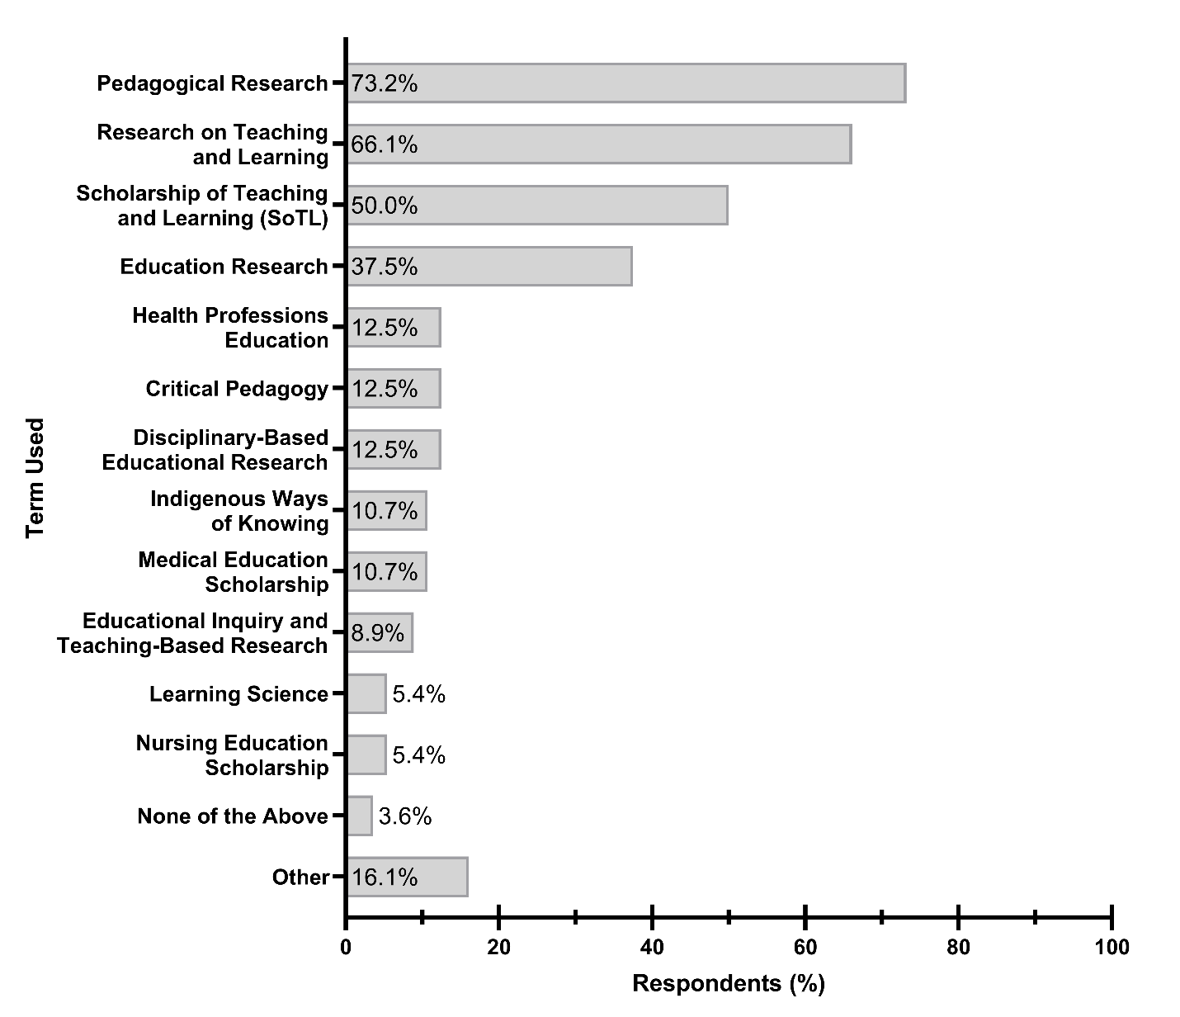
Figure 1. Terms used by respondents to describe teaching and learning research. N=56. Respondents could select multiple responses. N=56. Examples of “Other” terms used include Education Cognition Research, Anti-Racist Pedagogies, Health Education Scholarship, and Education Science.
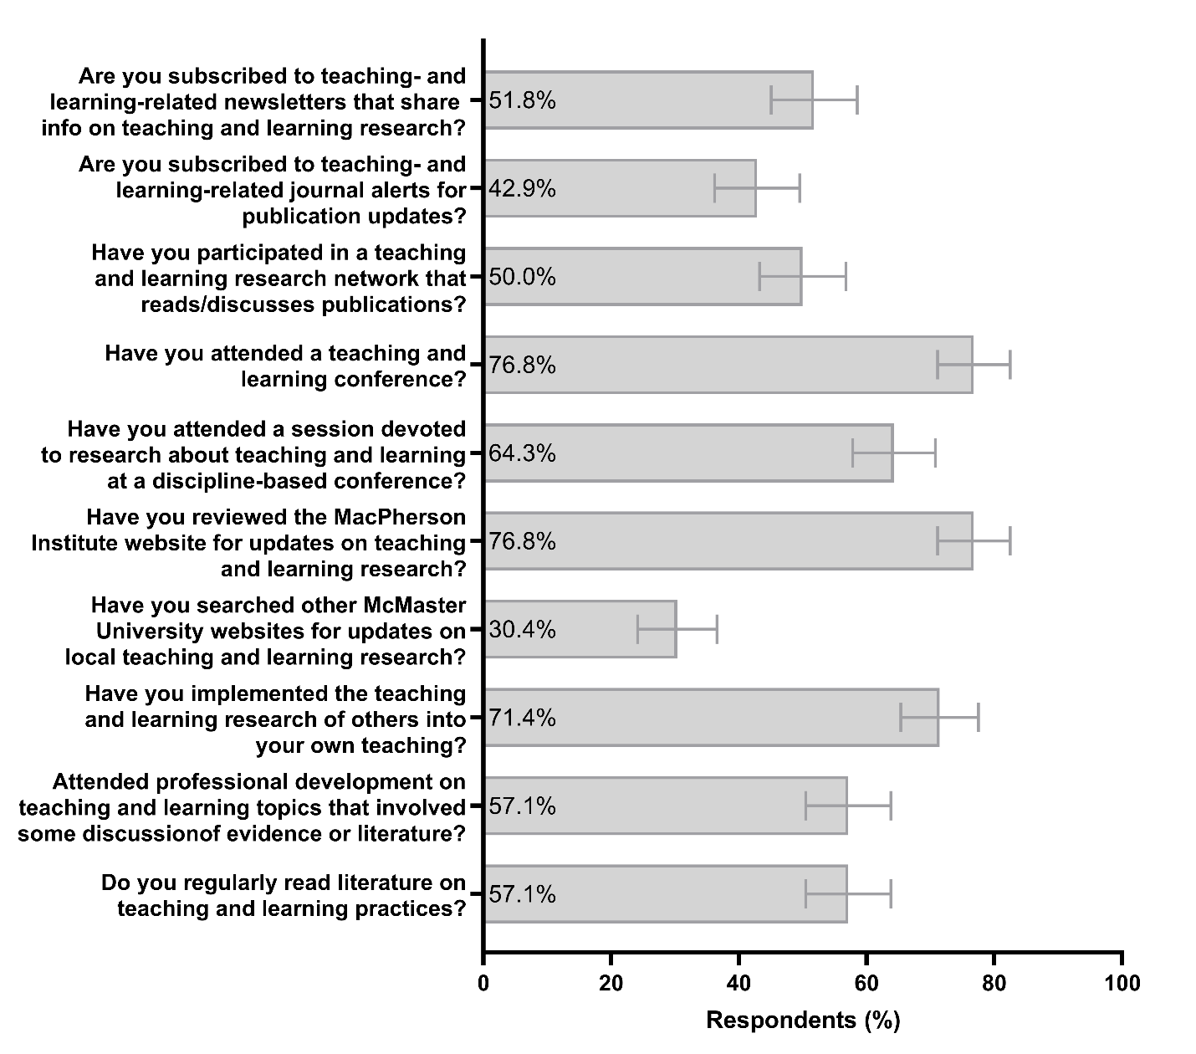
Figure 2. Information sources and activities used to stay informed about research on teaching and learning. N=56, error bars display standard error of the mean. Percentage value represents the proportion of respondents who answered ‘Yes’ to the listed questions.

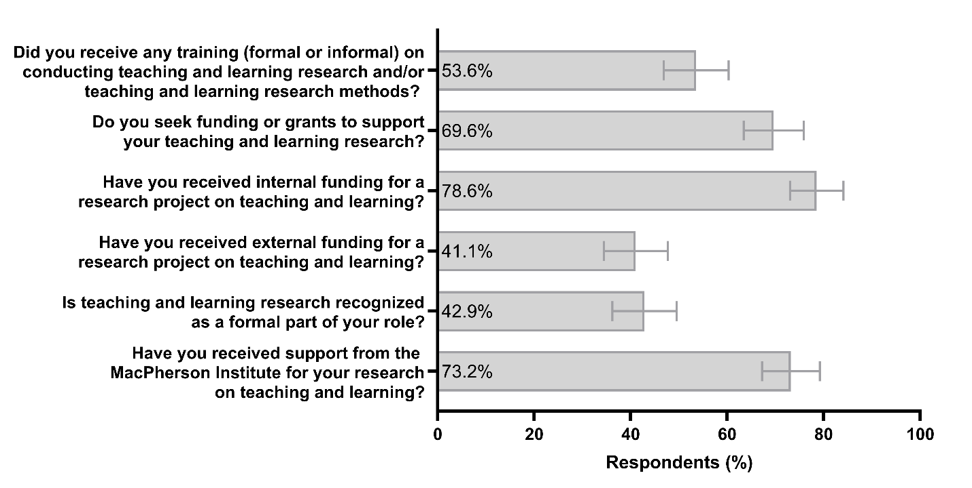
Figure 3. Activities completed by respondents in the past five years to support their research on teaching and learning. N=56, error bars display standard error of the mean. Percentage value represents the proportion of respondents who answered ‘Yes’ to the listed questions.

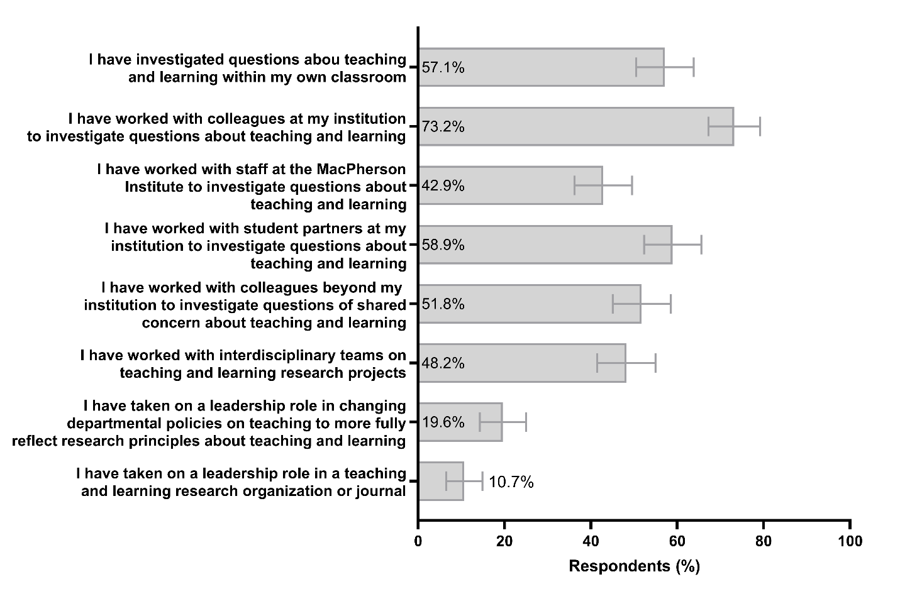
Figure 4. Scope of research on teaching and learning activities reported by respondents. N=56, error bars display standard error of the mean. Percentage value represents the proportion of respondents who answered ‘Yes’ to the listed statements.

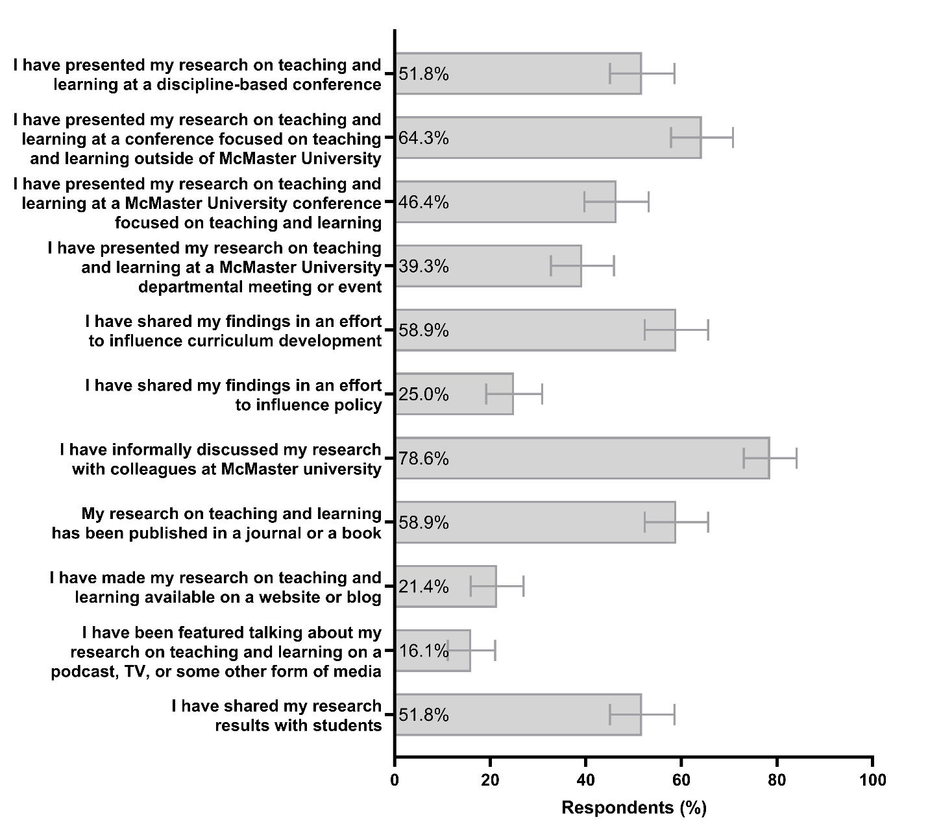
Figure 5. Research on teaching and learning dissemination methods reported by respondents. N=56, error bars display standard error of the mean. Percentage value represents the proportion of respondents who answered ‘Yes’ to the listed statements.

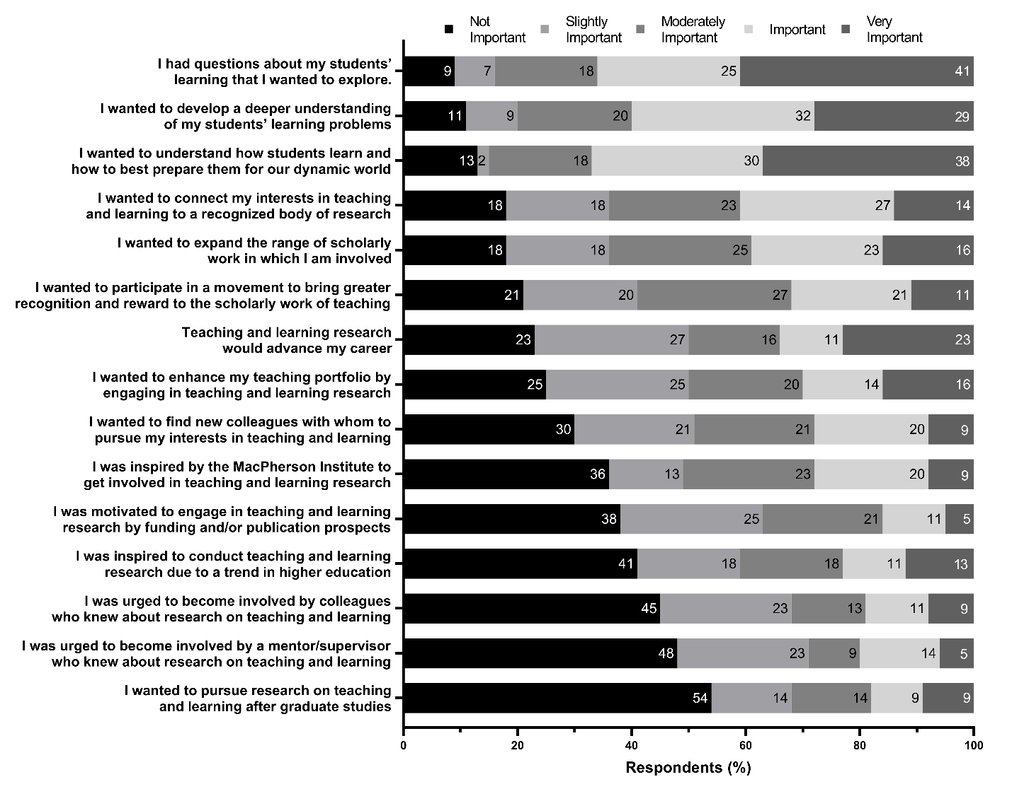
Figure 6. Motivations for engagement with research on teaching and learning. N=56. Percentage value represents the proportion of respondents who answered with the indicated Likert-type scale response for the given statement. Items are ranked from lowest to the highest percentage of respondents reporting the given statement was “Not Important” for their motivation.
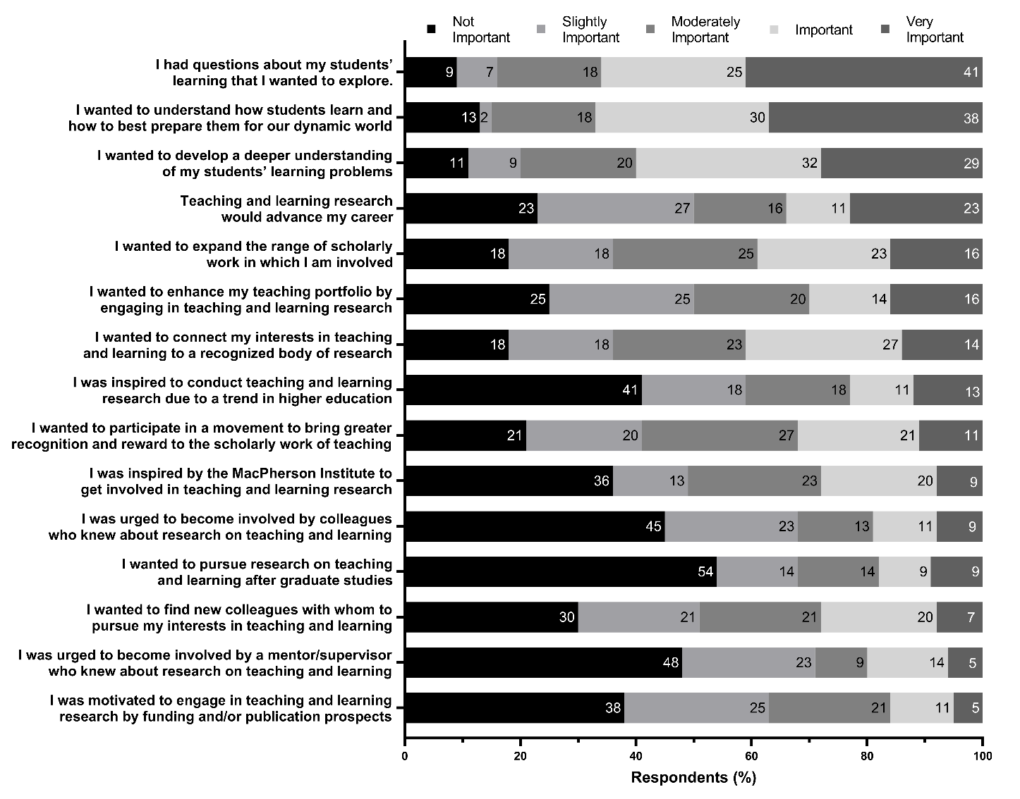

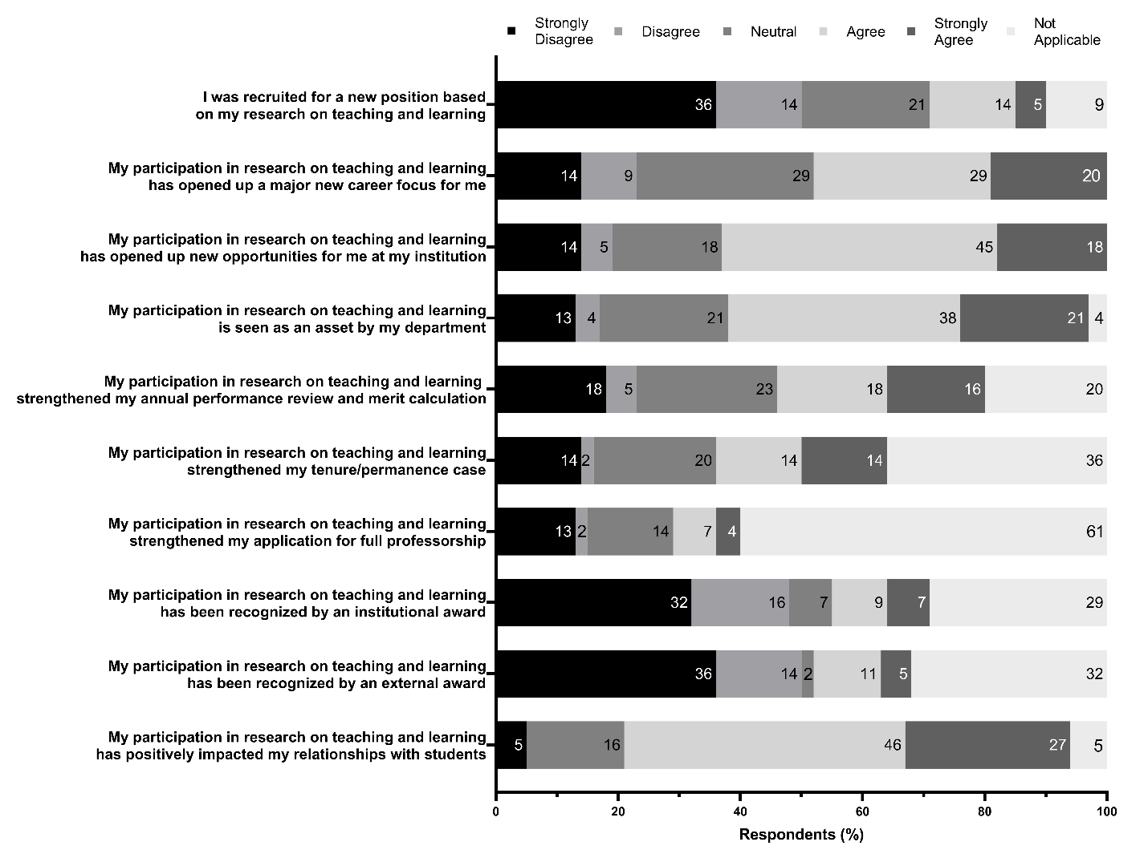
Figure 7. Respondent Outcomes for engagement with research on teaching and learning. N=56. Percentage value represents the proportion of respondents who answered with the indicated Likert-type scale response for the given statement.

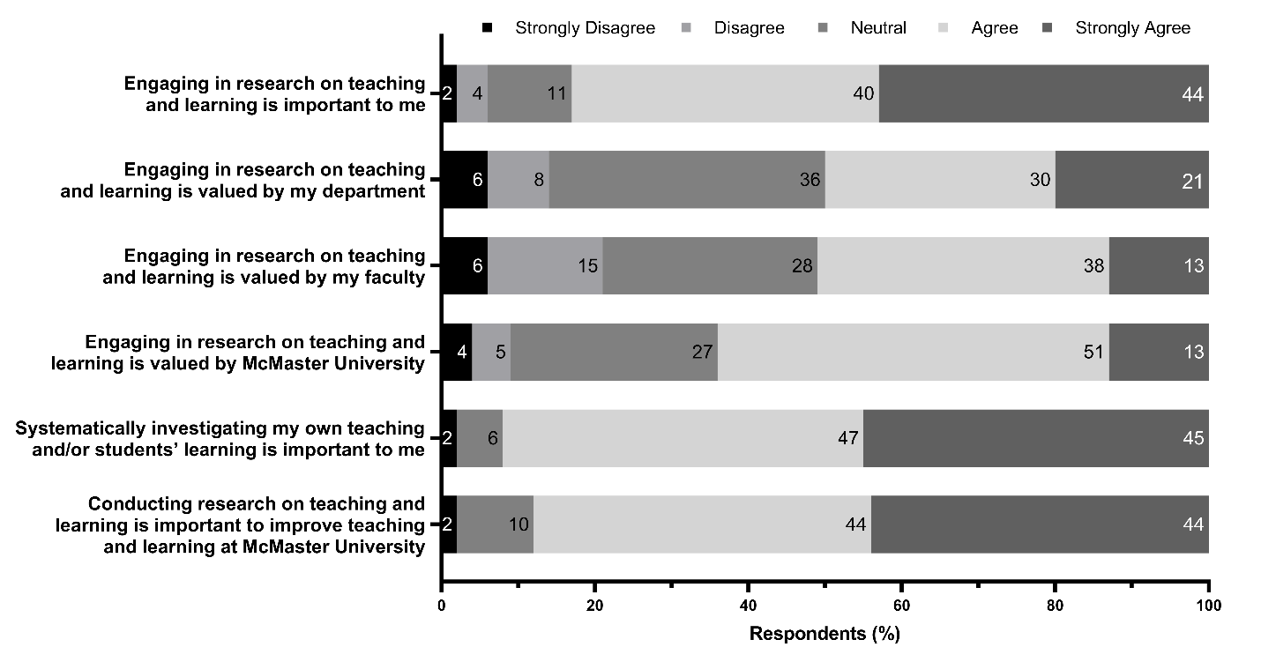
Figure 8. Respondent perceptions of values and importance of research on teaching and learning. N=52-55. Percentage value represents the proportion of respondents who answered with the indicated Likert-type scale response for the given statement.

References
Allen, M. N. & Field, P. A. (2005). Scholarly Teaching and Scholarship of Teaching: Noting the Difference. International Journal of Nursing Education Scholarship, 2(1).
Boshier, R. (2009). Why is the Scholarship of Teaching and Learning such a hard sell?, Higher Education Research & Development, 28(1), 1-15, doi: 10.1080/07294360802444321
Billot, J., Rowland, S., Carnell, B., Amundsen, C., & Evans, T. (2017). How experienced SoTL researchers develop the credibility of their work. Teaching and Learning Inquiry, 5(1), 101-114.
Boyer, E. (1990). Scholarship reconsidered: Priorities for the professoriate. The Carnegie Foundation for the Advancement of Teaching.
Brownell, S. E., & Tanner, K. D. (2012). Barriers to faculty pedagogical change: Lack of training, time, incentives, and… tensions with professional identity?. CBE—Life Sciences Education, 11(4), 339-346.
Carnegie Foundation for the Advancement of Teaching (2004). The CASTL survey: Developed by the Carnegie Academy for the Scholarship of Teaching and Learning (CASTL) Program. Retrieved from: http://archive.carnegiefoundation.org/publications/pdfs/tools-sharing/CASTL_survey.pdf
Charmaz, K. (2006). Constructing grounded theory: A practical guide through qualitative analysis. Sage.
Chen, C. J. (2021). SoTL enculturation guided by Kotter's model of change. International Journal for Academic Development, DOI: 10.1080/1360144X.2021.1890605
Centre for Teaching Support & Innovation. (2008) Scholarship of teaching and learning (SoTL). Retrieved from https://teaching.utoronto.ca/wp-content/uploads/2018/08/SoTL-Brochure-Aug-2018.pdf
Dalgarno, N., Laverty, C., Egan, R., Soleas, E., Garton, K., Babando, J., & van Wylick, R. (2020). Participant perceptions of the faculty development Educational Research Series. Teaching & Learning Inquiry, 8 (1). http://dx.doi.org/10.20343/teachlearninqu.8.1.15
Daniel, D. B., & Chew, S. L. (2013). The tribalism of teaching and learning. Teaching of Psychology, 40(4), 363-367. doi: 10.1177/0098628313501034
Darbyshire, P., MacDougall, C., & Schiller, W. (2005). Multiple methods in qualitative research with children: more insight or just more?. Qualitative Research, 5(4), 417-436.
DiGregorio, N., Maurer, T. W., & Pattanaik, S. (2016). Documentation of Scholarship of teaching and learning trends at National Council on Family Relations Annual Conferences 2006-2015. Family Science Review, 21(2).
Felten, P. (2013). Principles of good practice in SoTL. Teaching & Learning Inquiry, 1(1), 121-125.
Ginsberg, S. M., & Bernstein, J. L. (2011). Growing the scholarship of teaching and learning through institutional culture change. Journal of the Scholarship of Teaching and Learning, 1-12.
Hanson, A. (1996). The search for separate theories of adult learning: Does anyone need andragogy? In R. Edwards, A., Hanson, & P. Raggatt (Eds.), Boundaries of adults learning. Adult learners, education and training (Vol. 1, 99-109). Routledge.
Harland, T., Raja Hussain, R. M., & Bakar, A. A. (2014). The scholarship of teaching and learning: challenges for Malaysian academics. Teaching in Higher Education, 19(1), 38-48. DOI: 10.1080/13562517.2013.827654
Huber, M. T. & Hutchings, P. (2005). The advancement of learning: Building the teaching commons. Jossey-Bass.
Kolomitro, K., Laverty, C., & Stockley, D. (2018). Sparking SoTL: Triggers and stories from one institution. Canadian Journal for the Scholarship of Teaching and Learning, 9(1).
Kreber, C. (2002). Controversy and consensus on the Scholarship of Teaching. Studies in Higher Education, 27(2), 151–167.
Marcketti, S. B. & Freeman, S. (2016). Sotl evidence on promotion and tenure vitas at a research university. Journal of the Scholarship of Teaching and Learning, 16(5), 19-31. doi: 10.14434/josotl.v16i5.21152
MacPherson Institute. (2019). Strategic Plan 2019-2022.
MacPherson Institute. (2020). 2019-2020 year in review.
MacPherson Institute. (2022). About us. Retrieved from: https://mi.mcmaster.ca/about-us/
McKinney, K. (2006). Attitudinal and structural factors contributing to challenges in the work of the scholarship of teaching and learning. New Directions for Institutional Research, 129. Doi: 10.1002/ir.170
McMaster University. (2021). Inspiring excellence through collaboration: Teaching and learning strategy 2021-2026.
McKinney, K. (2007). Enhancing learning through the scholarship of teaching and learning: The challenges and joys of juggling. Boston: Anker.
Miller-Young, J. E., Anderson, C., Kiceniuk, D., Mooney, J., Riddell, J., Schmidt Hanbidge, A., Ward, V., Wideman, M. A., & Chick, N. (2017). Leading up in the scholarship of teaching and learning. The Canadian Journal for the Scholarship of Teaching and Learning, 8(2).
Newton, G., Miller-Young, J. & Sanago, M. (2019). Characterizing SoTL across Canada. The Canadian Journal for the Scholarship of Teaching and Learning, 10(2).
Simmons, N., & Marquis, E. (2017). Defining the scholarship of teaching and learning. The Canadian Journal for the Scholarship of Teaching and Learning, 8(2). https://doi.org/10.5206/cjsotl-rcacea.2017.2.2
Simmons, N. (2020). The 4M framework as analytic lens for SoTL’s impact: A study of seven scholars. Teaching & Learning Inquiry, 8(1), 76-90.
The Society for Teaching and Learning in Higher Education [STLHE]. (n.d.). What is SoTL. Retrieved February 2, 2021 from https://www.stlhe.ca/sotl/what-is-sotl/
Tam, M. (2014). A distinctive theory of teaching and learning for older learners: Why and why not? International Journal of Lifelong Education, 33(6), 811-820. https://doi.org/10.1080/02601370.2014.972998
Tavakol, M., & Dennick, R. (2011). Making sense of Cronbach's alpha. International Journal of Medical Education, 2, 53.
Tierney, A. (2017, April). Threshold concepts in academic practice: Engagement with the scholarship of teaching and learning. Practice and Evidence of Scholarship of Teaching and Learning in Higher Education, 12(2), 165-184.
Tight, M. (2018). Tracking the scholarship of teaching and learning. Policy Reviews in Higher Education, 2(1), 61-78.
Vajoczki, S., Savage, P., Martin, L., Borin, P. & Kustra, E. D. H. (2011, September). Good teachers, scholarly teachers, and teachers engaged in scholarship of teaching and learning: A case study from McMaster University, Hamilton, Canada. The Canadian Journal for the Scholarship of Teaching and Learning, 2(1). https://doi.org/10.5206/cjsotl-rcacea.2011.1.2
Vander Kloet, M.; Frake-Mistak, M.; McGinn, M. K.; Caldecott, M.; Aspenlieder, E. D.; Beres, J. L.; Fukuzawa, S.; Cassidy, A.; & Gill, A. (2017). Conditions for contingent instructors engaged in the scholarship of teaching and learning. The Canadian Journal for the Scholarship of Teaching and Learning, 8(2).
Vithal, R. (2018). Growing a scholarship of teaching and learning institutionally. Studies in Higher Education, 43(3), 468-483, DOI: 10.1080/03075079.2016.1180350
Webb, A. S. (2020). Riding the fourth wave: An introduction to the scholarship of teaching and learning (Chapter 1). In R. C. Plews & M. L. Amos (Eds) Evidence-Based faculty develop through the scholarship of teaching and learning (SoTL). IGI Global.
Wuetherick, B., & Yu, S. (2016). The Canadian teaching commons: The scholarship of teaching and learning in Canadian higher education. New Directions for Teaching and Learning, 146, 23-30.
Yin, R. K. (2003). Case study research: Design and methods (3rd ed.). Sage.

Due to the vast number of possible terms, we did solicit for ‘other’ options respondents used. Also due to these space limitations, we could include all possible terminology used to describe teaching and learning scholarship. For example, we did not consider the term andragogy (Knowles, 19080). The reason for this exclusion is that the “agogy” continuum (I.e., pedagogy for children, andragogy for adults, and geragogy for older adults) is contested in the field of education (Tam, 2014). Such age-graded theorizations of learning can obfuscate similarities in learning across the life course, serve to create exclusive learning environments that segregate learners based on age, and contribute to stigmatization and marginalization of learners based on ageism and other forms of age bias (Hanson, 1996; Tam, 2014)
For a copy of the journal title mining results, please email one of the lead authors of this report.
For a copy of the survey tool, please email one of the lead authors of this report.
For a copy of the interview guide, please email one of the lead authors of this report.

